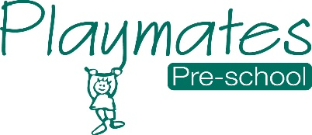
09 Standard Childcare Practice
09.8 Prime times – Snack-times and mealtimes (older children)
Snack times
- A ‘snack’ is provided by parents for children attending for the morning session.
- Children may also take turns to help set the table. Small plastic jugs are provided with choice of milk or water.
- Children wash their hands before and after snack-time.
- Children are offered semi-skimmed milk as a main drink, as long as they are eating a varied and balanced diet.
- Children who are unable to drink cow’s milk due to dietary or allergy reasons will be offered a milk alternative as agreed with parents, such as soya or oat milk.
- Fresh fruit is always available to supplement the snack the child has brought in
- Portion sizes are gauged as appropriate to the age of the child.
- Children arrive as they want refreshment and leave when they have had enough. Children are not made to leave their play if they do not want to have a snack.
- Staff join in conversation and encourage children’s independence by allowing them to pour their own drinks and put their rubbish into the recycling or rubbish bin.
Mealtimes
- Tables are never overcrowded during mealtimes.
- Children help staff to set out the chairs for lunchtime.
- Tables are cleaned thoroughly with antibacterial spray before and after lunchtime, and chairs are cleaned this way afterwards too.
- Children wash their hands, get their lunchboxes and choose a seat at the table.
- Staff have their lunch with children and role-model healthy eating and best practice at all times, for example not drinking cans of fizzy drinks in front of the children.
- Children are given time to eat at their own pace and are not hurried to fit in with adults’ tasks and breaks. They are not made to eat what they do not like.
- In order to protect children with food allergies or specific dietary requirements, children are discouraged from sharing and swopping their food with one another.
- If children do not eat their main course, they are not denied pudding. Food is not used as a reward or punishment.
- Mealtimes are relaxed opportunities for social interaction between children and the adults who care for them.
- After lunch, children are encouraged to put their lunchboxes on the trolley before they go to play.
- Information for parents on healthy lunchboxes is provided on Tapestry.

