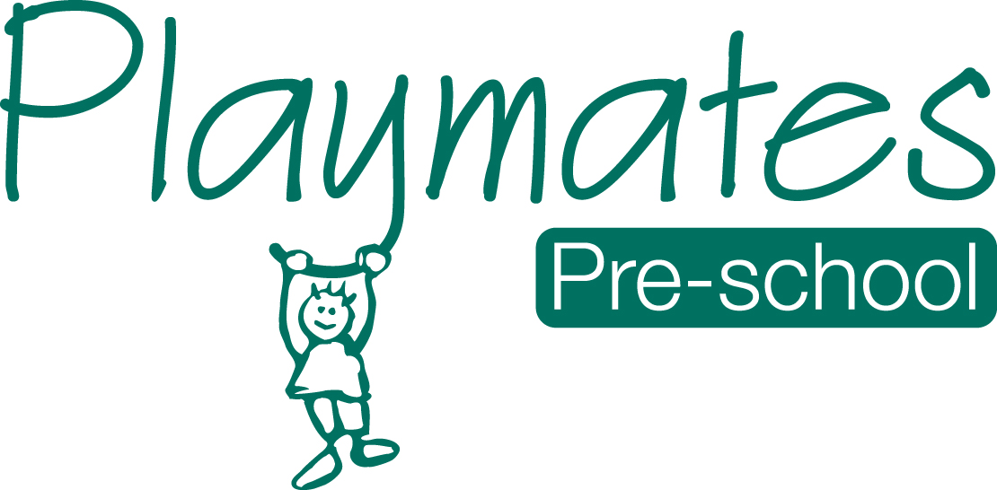
07.1a Privacy notice
Playmates Pre-school’s Privacy Notice
Playmates Pre-school, The Log Cabin, Whitelands Park School, Sagecroft Road, Thatcham, RG18 3FH.
Introduction
Personal data is protected in accordance with data protection laws and used in line with your expectations. This privacy notice explains what personal data we collect, why we collect it, how we use it, the control you have over your personal data and the procedures we have in place to protect it.
When we refer to “we”, “us” or “our”, we mean Playmates Pre-school.
What personal data we collect
We collect personal data about you and your child to provide care and learning tailored to meet your child’s individual needs. Personal details that we obtain from you includes your child’s: name, date of birth, address, and health, development and any special educational needs information. We will also ask for information about who has parental responsibility for your child and any court orders pertaining to your child.
Personal data that we collect about you includes: your name, home and work address, phone numbers, email address, emergency contact details, and family details.
We will only with your consent collect your national Insurance number or unique taxpayer reference (UTR) where necessary if you are self employed and where you apply for up to 30 hours free childcare. We also collect information regarding benefits and family credits. Please note that if this information is not provided, then we cannot claim funding for your child.
We also process financial information when you pay your childcare fees by chip and pin or direct debit. We may collect other data from you when you voluntarily contact us.
Where applicable we will obtain details of your child’s social worker, child protection plans from social care, and health care plans from health professionals and other health agencies.
We may collect this information in a variety of ways. For example, data will be collected from you directly in the registration form; from identity documents; from correspondence with you; or from health and other professionals.
Why we collect personal data and the legal basis for handling your data
We use personal data about you and your child in order to provide childcare services and to fulfil the contractual arrangement you have entered into. This includes using your data in the following ways:
- to support your child’s wellbeing and development
- to effectively manage any special education, health or medical needs of your child whilst at the setting
- to carry out regular assessment of your child’s progress and to identify any areas of concern
- to maintain relevant contact about your child’s wellbeing and development
- to contact you in the case of an emergency
- to process your claim for free childcare, if applicable
- to enable us to respond to any questions you ask
- to keep you updated about information which forms part of your contract with us
- to notify you of service changes or issues
- to send you our e-newsletter, if you have subscribed to it
With your consent, we would also like to:
- collect your child’s ethnicity and religion data for monitoring purposes
- record your child’s activities for their individual learning journal (this will often include photographs and videos of children during play)
- sign you up for our free parent e-newsletter which provides resources and useful information for parents
- transfer your child’s records to the receiving school when s/he transfers
If we wish to use any images of your child for training, publicity or marketing purposes we will seek your written consent for each image we wish to use. You are able to withdraw your consent at any time, for images being taken of your child and/or for the transfer of records to the receiving school, by confirming so in writing to the setting. You can also unsubscribe from receiving our parent e-newsletter by notifying the setting.
We have a legal obligation to process safeguarding related data about your child should we have concerns about her/his welfare.
Who we share your data with
As a registered childcare provider in order to deliver childcare services it is necessary for us to share data about you and/or your child with the following categories of recipients:
- Ofsted, when there has been a complaint about the childcare service or during an inspection
- banking services in order to process chip and pin and/or direct debit payments
- the local authority, if you claim up to 30 hours free child care
- the governments eligibility checker as above, if applicable
- our insurance underwriter, where applicable
- an email newsletter service, where you have given consent to receive our e-newsletter
We will also share your data:
- if we are legally required to do so, for example, by a law enforcement agency, court
- to enforce or apply the terms and conditions of your contract with us
- to protect your child and other children; for example, by sharing information with medical services, social services or the police
- if it is necessary to protect our rights, property or safety or to protect the rights, property or safety of others
- with the school that your child will be attending, when s/he transfers, if applicable
- if we transfer the management of the setting out or take over any other organisation or part of it, in which case we may disclose your personal data to the prospective seller or buyer so that they may continue using it in the same way
Our nursery management and communication software provider may be able to access your personal data when carrying out maintenance task and software updates on our behalf. However, we have a written agreement in place which place this company under a duty of confidentiality.
We will never share your data with any organisation to use for their own purposes.
How do we protect your data?
We take the security of your personal data seriously. We have internal policies and strict controls in place to try to ensure that your data is not lost, accidentally destroyed, misused or disclosed and to prevent unauthorised access.
Where we engage third parties to process personal data on our behalf, they are under a duty of confidentiality and are obliged to implement appropriate technical and organisational measures to ensure the security of data.
Where do we store your data?
All data you provide to us is stored on secure computers or servers located within the UK or European Economic Area. We may also store paper records in locked filing cabinets.
Our third party data processors will also store your data on secure servers which may be situated inside or outside the European Economic Area. They may also store data in paper files.
How long do we retain your data?
We retain your data in line with our retention policy a summary is below:
- You and your child’s data, including registers are retained 3 years after your child no longer uses the setting, or until our next Ofsted inspection after your child leaves our setting.
- Medication records and accident records are kept for longer according to legal requirements.
- Learning journeys are maintained by the setting and available at your request when your child leaves. Records are kept and archived in line with our data retention policy.
- In some cases (child protection or other support service referrals), we may need to keep your data longer, only if it is necessary in order to comply with legal requirements. We will only keep your data for as long as is necessary to fulfil the purposes it was collected for and in line with data protection laws.
Your rights with respect to your data
As a data subject, you have a number of rights. You can:
- request to access, amend or correct the personal data we hold about you and/or your child
- request that we delete or stop processing your and/or your child’s personal data, for example where the data is no longer necessary for the purposes of processing or where you wish to withdraw consent
- request that we transfer your and your child’s personal data to another person
If you wish to exercise any of these rights at any time please contact the manager at the setting by email, telephone or when you attend the setting.
How to ask questions about this notice
If you have any questions, comments or concerns about any aspect of this notice or how we handle your data please contact the manager at the setting.
How to contact the Information Commissioner Office (ICO)
If the manager is not able to address your concern, please contact [Insert details of setting manager’s line manager/owner/director/trustee]
If you are concerned about the way your data is handled and remain dissatisfied after raising your concern, you have the right to complain to the Information Commissioner Office (ICO). The ICO can be contacted at Information Commissioner’s Office, Wycliffe House, Water Lane, Wilmslow, Cheshire, SK9 5AF or https://ico.org.uk/.
Changes to this notice
We keep this notice under regular review. Any changes to this notice will be shared with you so that you may be aware of how we use your data at all times.

