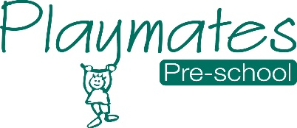
03 Food safety and nutrition procedures
03.4 Menu planning and nutrition
Food supplied for children provides a healthy and balanced diet for healthy growth and development. Foods that contain any of 14 allergens identified by the FSA are identified on menus. The setting follows dietary guidance to promote health and reduce risk of disease caused by unhealthy eating. When planning menus, the setting manager and cook ensure that:
- Parents and staff are able to contribute ideas for menus which are confirmed each week in advance. A four- to six-week cycle reviewed seasonally is a good way of working out menus.
- Menus reflect children’s cultural backgrounds, religious restrictions and the food preferences of some ethnic groups.
- Menus are clearly displayed so that parents and staff know what is being provided.
- Foods that contain any of the 14 major allergens are identified on the menu that is displayed for parents.
- Parents must share information about their children’s particular dietary needs with staff when they enrol their children and on an on-going basis with their key person.
- Key persons regularly share information about the children’s levels of appetite and enjoyment of food with parents.
- Staff refer to the Eat Better, Start Better (Action for Children 2017).
- The cook maintains a record of children’s dietary needs in a Food Allergy and Dietary Needs folder.
Pre-prepared cook chilled meals and hot meals from suppliers
If the setting uses a food supplier to provide either hot meals prepared off site or chilled/frozen meals to be heated on site, the supplier’s instructions for safe storage, heating and serving must be followed.
- Ingredients are checked to identify allergens (this will be clearly indicated on packaging).
- A temperature probe is used to check that cook chilled foods are heated correctly.
- Foods delivered hot are checked as above.
- Foods are served within the time stipulated by the supplier.
- Left-overs are not kept and reheated for another day.
- The guidance in Safer Food Better Business (Food Standards Agency 2020) is followed at all times.

Packed lunches
Where children have packed lunches, staff promote healthy eating, ensuring that parents are given advice and information about what is appropriate content for a child’s lunch box. Parents are also advised to take measures to ensure children’s lunch box contents remain cool i.e. ice packs, as the setting may not have facilities for refrigerated storage.

